Iterate on Existing

* Abstract - 5pts **(Yichen)**
* Introduction - 5pts **(Yichen)**
  + Problem
  + Obstacles = Knowledge of context of use & gaps/breakdowns (User Requirements) we identified in assignment 2
  + Solution = Final Design we come up with
  + Takeaway = Insights we gathered in this design iteration (the design critiques maybe)

Probably no need to further iterate on related work I believe

* Related work - 5pts **(Daniel)**
  + Stated we need to make sure there's at least one solution proposed in the past
  + Solutions that exist in the context of use (one-handed mobile text entry)

Group work – 1:06:00, Lecture 10/19

* Individual Sketches & Storyboards Design Critique - 10 pts **(Daniel)**
  + This part is about documenting what is good/needs improvement about the individual designs.
  + Critiques also need to document what is **good** about the design!
  + Critiques are not necessarily cons but how can we improve it
    - Nothing negative
  + **Pick the features we want to keep/improve** (specifically, if multiple features address just 1 user requirement, we should just keep 1).
* Final **Primary** Persona - 10 pts **(Jack - Isaac, anyone can add more into it if you want)**
  + Can choose to either
    - Combine all 5 personas into one primary persona
    - Combine some (not all) personas into one primary persona
      * Others are combined into secondary persona or even anti-persona (not required)
* Final sketches & storyboards - 10 pts **(Jerry, Isaac)**
  + Sketches & storyboards for final design
    - **Jerry’s adjustable shifted keyboard**
      * **allow user to slide the keyboard to choose how much they want to squish it**
      * **How do we switch from two hands to one hand?**
        + **swipe the space key**
    - **Jerry’s punctuation key on the bottom right**
    - **Jerry’s slide to delete**
    - **Jerry’s lists of possible words**
      * **most likely used words at the top, and least likely at the bottom**
      * **Use ML to more accurately predict what the user was trying to type & give the suggested list of autocorrect words**
    - **How do we switch from two hands to one hand?**
      * **swipe the space key**
  + Does the description contain justification for changes based on the design critiques?
* Final paper prototype - 10 pts **(Jerry, Franklin, Yichen, Isaac)**
  + Need a way to standardize this
  + Frames
    - Main Frame (Sketch 1)
  + Does the description contain justification for changes based on the design critiques?
  + 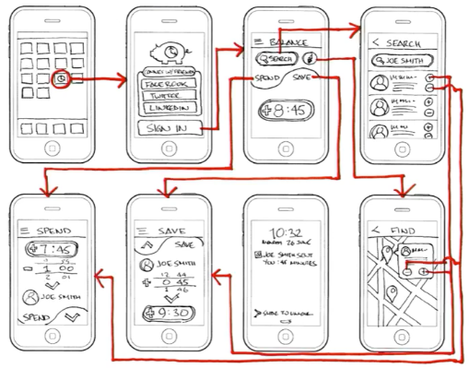
* Discussion (Daniel, Franklin)
* Conclusion (Yichen)

Easy

* Remaining = appendix